MACH4METAL

metalworking machinery
Transito 21
6909 DA BABBERICH Netherlands
Tel. +31 (0)316-247123
Fax: +31 (0)316-247956
info@mach4metal.com
www.mach4metal.com

Bank No : 66.52.13.883
IBAN : NL33 INGB 0665 2138 83
BIC : INGBNL2A

HAEUSLER 4 roll 3000 x 60 / 40
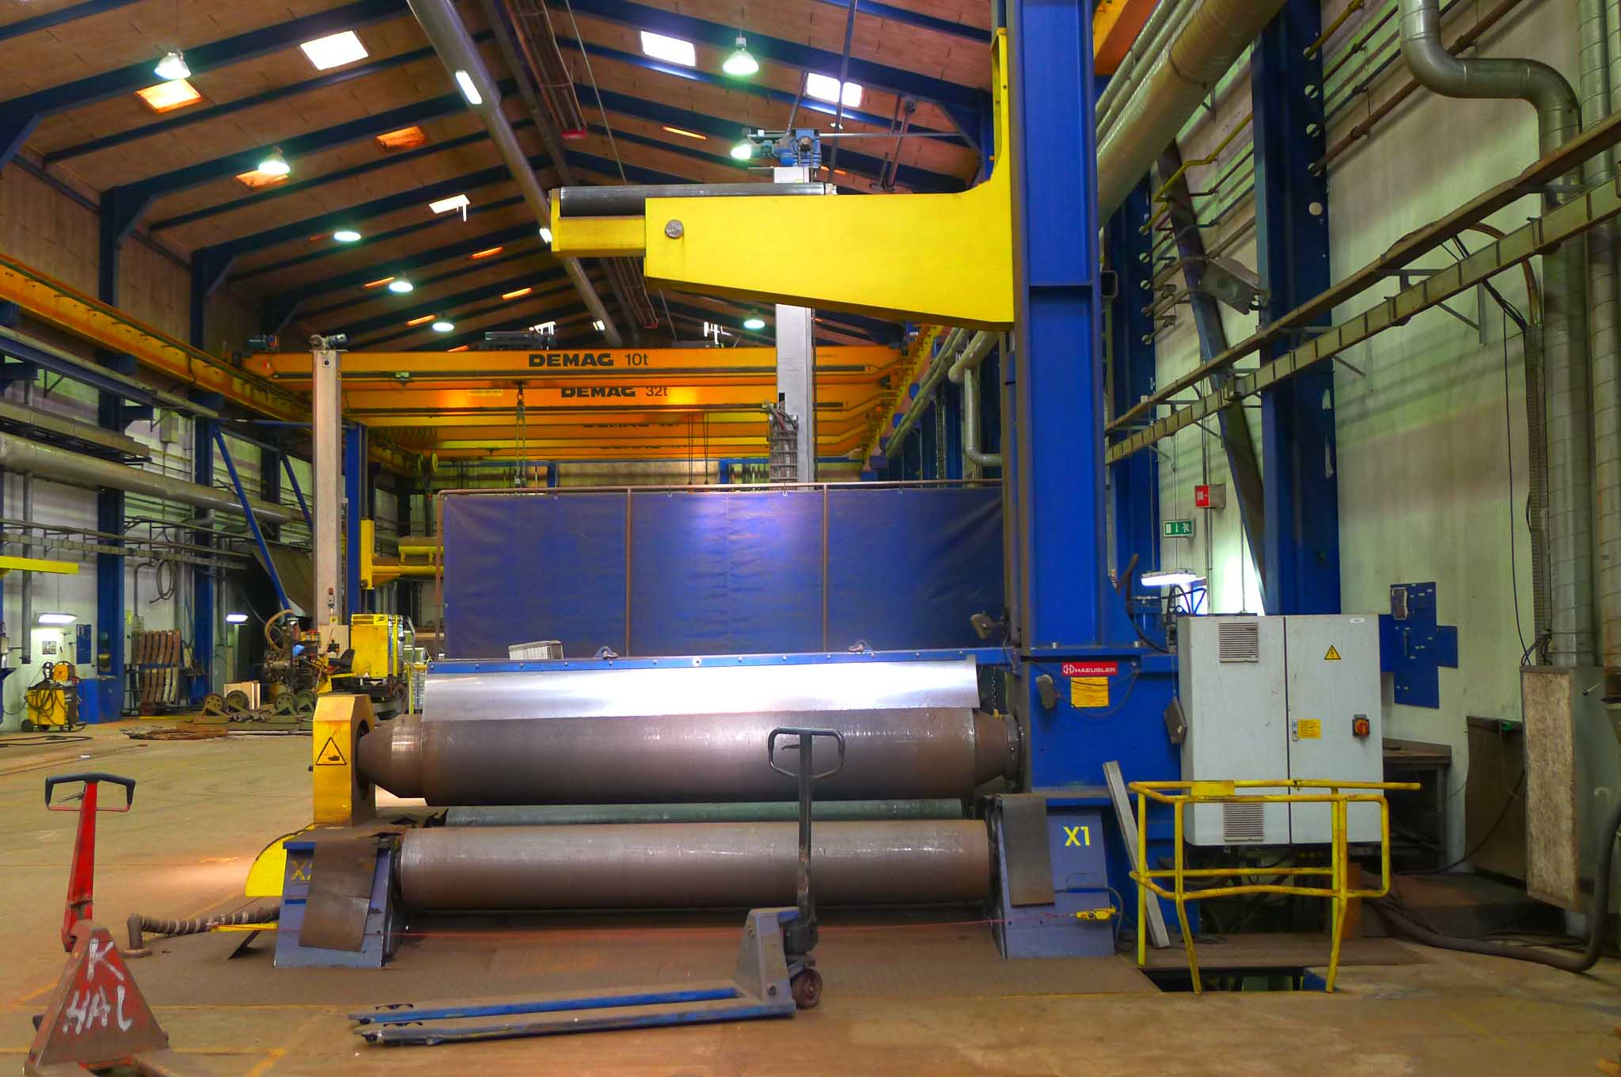

- Make : HAEUSLER SWISS
- Typ : VRM HY 3000 x 40
- Serial : WO 062 - 1954
- Age : 2007

- bending length : 3000 mm
Bending capacity
- Ø 2500 : 3000 x 60
- Ø 1500 : 3000 x 45
Pre Bending capacity
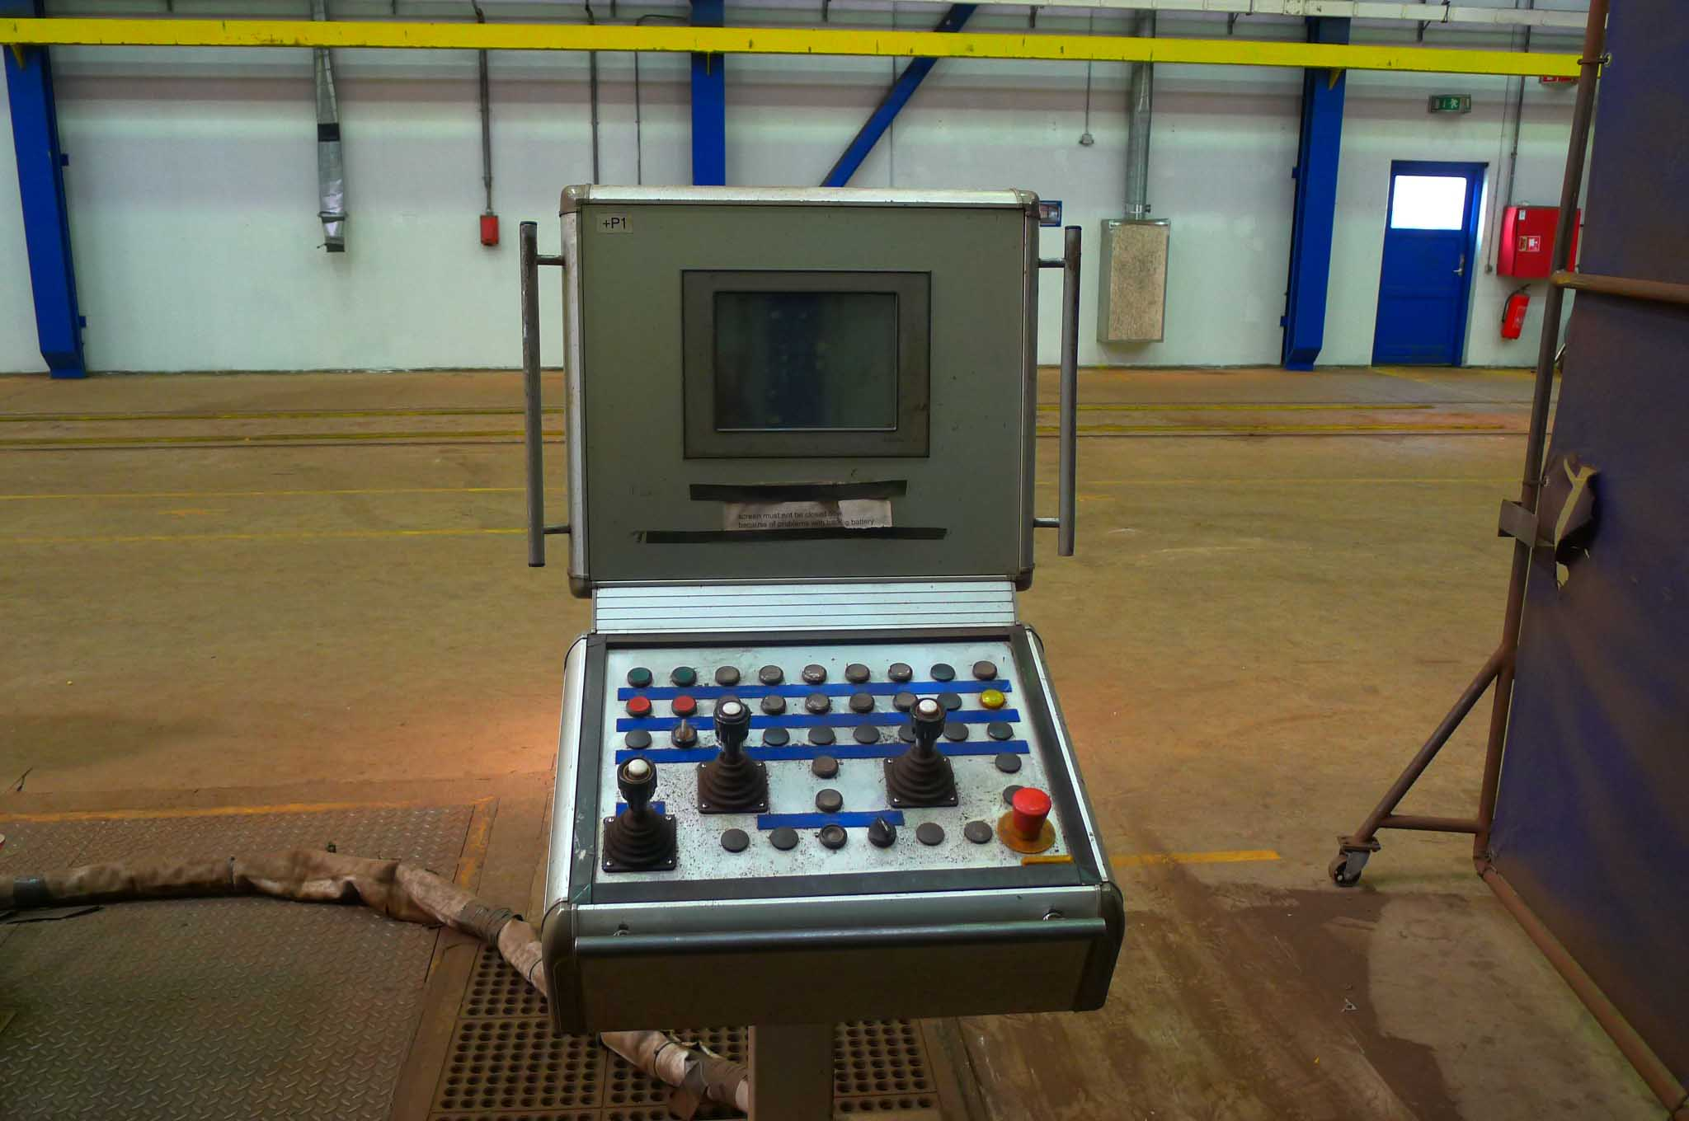
- Ø 2500 : 3000 x 40
- Ø 1500 : 3000 x 35

- Top roll Ø : 570
- Lower roll Ø : 540
- Side roll Ø : 420

- Minimum bending Ø : 650
- Force / pressure : 370 Ton

- Working speed: 2 / 4 / 6 M/min
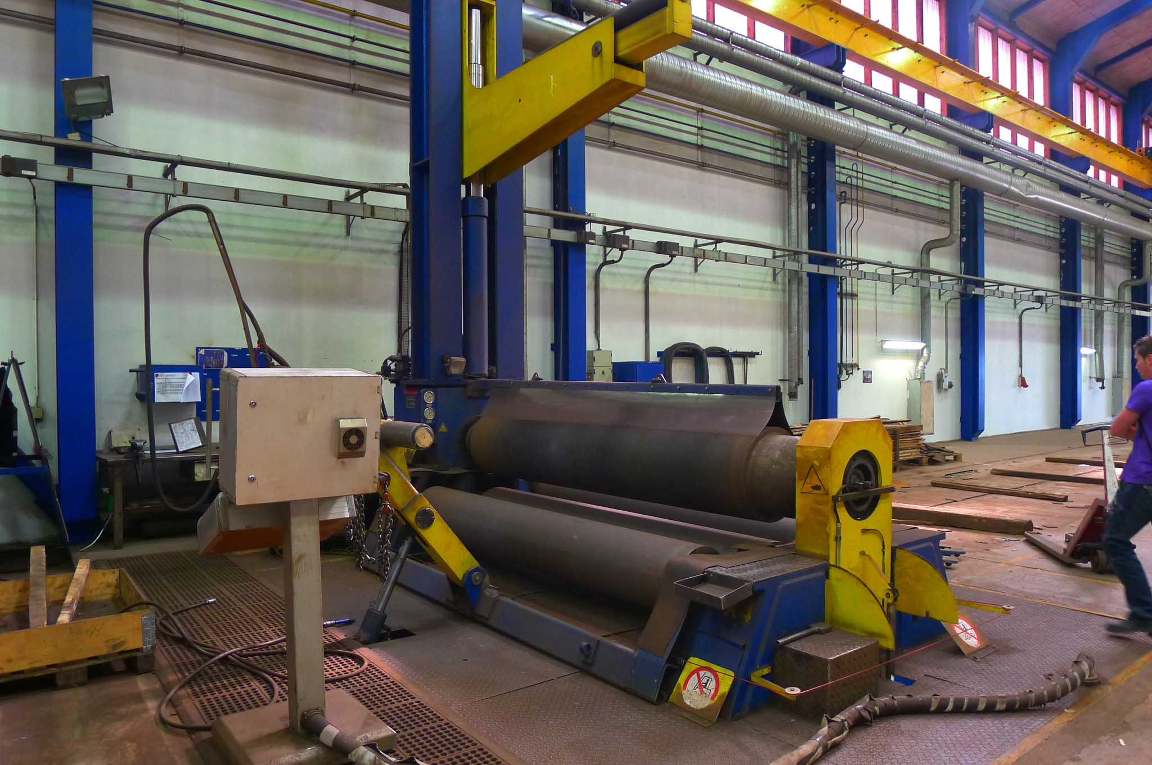
- 2 roll driven 55 kW

- Digital position 4 x side roll 0.1 mm
- Digital position 2 x lower roll 0.1 mm

- Weight : 45.000 Kg
- New price Euro 500.000
- Hydr. top support : 5.000 mm
- Hydr. side support

Please Note: The above information has been obtained to the best of our ability and belief from, and from the manufacturers where possible. It is given in good faith, but its accuracy can not be guaranteed. Accordingly, it will not form a representation or constitute contractual terms. We advise you to check any vital details!

